Contents

Artefact 1 – BPNM Process 2

Artefact 2 – Database Design 3

Artefact 3 – Peer Review Research 4

Artefact 4 – Peer Review Draft 5

Artefact 5 – Learned Programming Languages 6

# Note

The full artefacts are available above this document.

# Artefact 1 – BPNM Process

To conceptualize what tasks my team had to do I created a BPNM Process. This model focuses on the actions of the client to start attending an event. It involves both stages of event attending including the website features and the real life validations. To create the model I had to research how a BPNM model works, as I have never worked with BPNM. But with experience from my previous class, Modelling Information Systems, I quickly realized how the models elements work and created the BPNM model to help me explain to my team how I created the tasks.

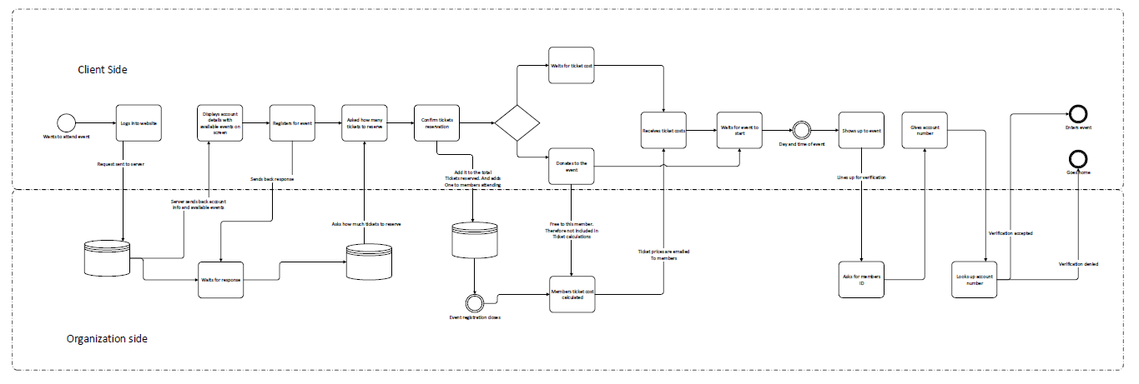

# Artefact 2 – Database Design

In the project we had to create a database to store all the information that was needed. To help my team to understand all the tables involved in the database and how they relate I created the database design. The database design is in crow’s notation diagram format, in which it just shows the relation of each table from each other. I then added some text to help the other team member’s understand what I wanted done for that specific table.

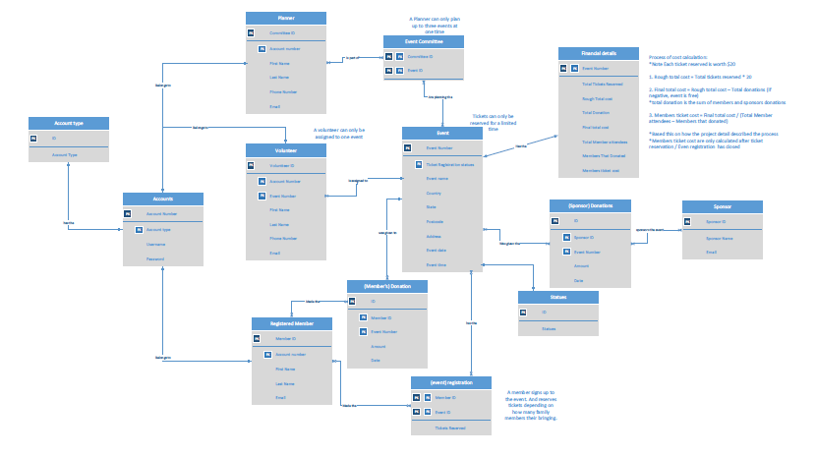It was pretty easy to create the database design as I had experience from my previous class, Modelling Information Systems. However the implementation from model to real design was a little bit trickier. This was mainly involved with the foreign key constraints.

# Artefact 3 – Peer Review Research

In the first release we had to create a peer review of our clients sprint one presentation. The review had to be in a business letter format. To help my team understand how to write in business letter format and having never wrote a business letter, I had to research everything about business letter.

To make sure the business letter we were writing were of industry standard, I researched sample business letters formats. From the website below I found multiple business letter formats, they all looked pretty similar, with minor differences. So I mainly just stuck with the format one when writing the business letter.

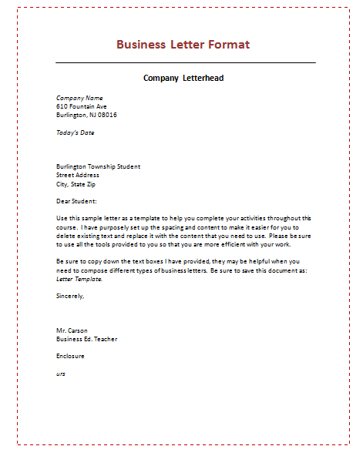

For further research and to act as a guide to how to write a business letter I looked at another website. This website provided specification on how a business letter is formatted. It provides information on everything that is involved with a business letter and why text is in the place that it is. I then used this as a guide and but used both the client and development team’s information. The website used one specific email from the sender to the receiver, I changed this to our teams, with the emails of the every team member put in.

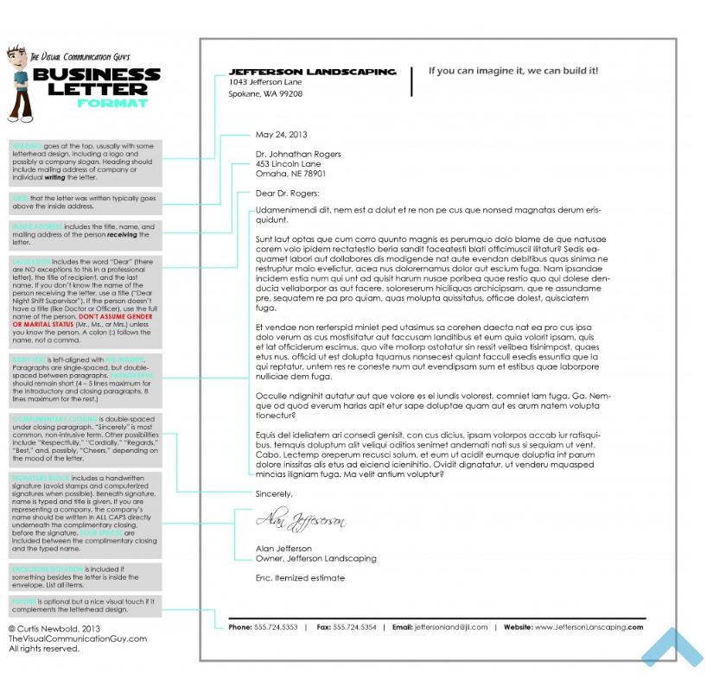

# Artefact 4 – Peer Review Draft

After researching how to write a business letter. I then wrote up the first draft of the business letter. I wrote everything that was in CRA of the assignment. Including the: Preparedness, Expectations, Technical and Professionalism. I then shared this with my team, which pretty much just reworded everything I wrote.

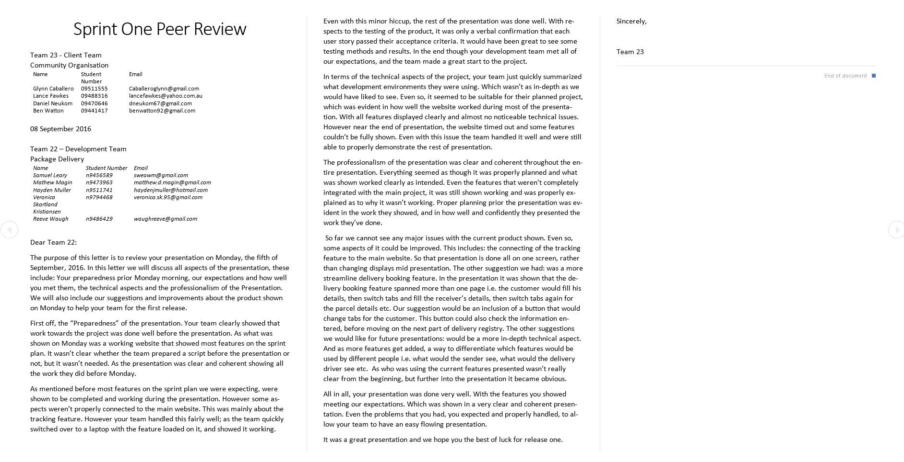

# Artefact 5 – Learned Programming Languages

To help my team develop the website I had to learn a number of programming languages. Most of these languages were mainly involved with website coding. Being in a computer science major I had previous experience with coding, but most of the languages that I had experience in were: C, C# and python. The languages I had to learn were: HTML, CSS, MySQLI and PHP. Although I had some experience with sql from high school, they were pretty basic and I had to relearn most of these.

To help me develop the login feature I followed the two tutorials below. The first one was mainly involved with the login code logic, as in how the php made sure the user could login or failed if they haven’t registered. While the second one delved into more about the login css and html styling, while still having similar php logic. I followed the first one’s logic more, while the second tutorials css and html styling more.

<https://www.youtube.com/watch?v=740kEwoRPKk>

<https://www.youtube.com/watch?v=J5RHnJCy8AE>

To help me with the main pages of the website I mainly just followed one tutorial. Although the turorial included php coding that worked similar with login. I mainly just followed how to write in css and html. From this tutorial I learned how divs work and how to create the menu tabs.

<https://www.youtube.com/watch?v=kIuQpPPgSOA>

To help me display the required information in tables in html I followed one tutorial. The tutorial was pretty straight forward, with minimal stylings. So I pretty much followed it to the letter.

<https://www.youtube.com/watch?v=X8ZcZXCXu50>

During development I had to reference a number websites, so that I could understand how the functions worked.

For the mysqli these were mainly involved with the creating the foreign keys in the database. As I have never done that before. While also relearning the update and insert into functions as its been awhile since high school.

<http://dev.mysql.com/doc/refman/5.7/en/create-table-foreign-keys.html>

<http://www.w3schools.com/php/php_mysql_update.asp>

<http://www.w3schools.com/php/php_mysql_insert.asp>

Having never worked with php before. I had zero experience with how php worked. However after learning the basic functions of how to connect to the database and how to create session variables, the code logic of php were pretty similar to my previous experiences with coding.

<http://php.net/manual/en/function.mysqli-connect.php>

<http://php.net/manual/en/book.session.php>

General references to html and css stylings so that I new what they did.

<http://www.w3schools.com/html/html_forms.asp>

<http://www.w3schools.com/css/css_margin.asp>

<http://www.w3schools.com/cssref/css3_pr_background-size.asp>

http://www.w3schools.com/cssref/